**LAB 10:**  **OPERATIONAL AMPLIFIERS**

Name:

**Objectives:**

1. To examine the characteristics of operational amplifier circuits in a few typical applications.
2. To discover some of the basic limitations of op-amps.

**Learning Outcomes:**

Able to analyze the characteristics and limitations of operational amplifier circuits in a few typical applications.

**Instrument/Component:**

Variable DC Power Supply

Function Generator

Oscilloscope

Digital Multimeter

Op-Amp 741

Resistors: 4.7kΩ, 10kΩ, 100kΩ

Potentiometer 10 kΩ

Capacitor 0.1uF

# **Prelab**

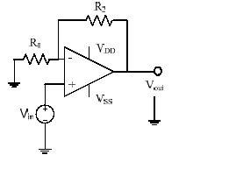Derive the gain (Vout/Vin) expression in terms of R1 and R2 for the following amplifier:

**Figure 10.1**

**Task 1: DC measurements**

1. Construct the non-inverting amplifier as shown in Fig 10.2. Let VDD be +6V and VSS be -4V. R1 is 4.7k and R2 is 4.7k. Vary Vi from -2V to 3V and record the Vo. Find the gain for each pair to verify the proper amplification range of DC inputs.

Answer:

|  |  |  |  |  |  |  |  |  |  |  |
| --- | --- | --- | --- | --- | --- | --- | --- | --- | --- | --- |
| **Input (Vi)** |  |  |  |  |  |  |  |  |  |  |
| **Output (Vo)** |  |  |  |  |  |  |  |  |  |  |
| **Gain** |  |  |  |  |  |  |  |  |  |  |

Proper amplification range (output voltage range):_______________

1. Fix the DC input 0.5V, measure the amplifier gain (Vo/Vi) for R2= 2 k, 4.7k, 10kΩ (turn R2) and compare with the calculated gain. (You need to take out the pot from the circuit to measure its value).

Answer:

|  |  |  |  |
| --- | --- | --- | --- |
| **R2 (Ω)** |  |  |  |
| **Theoretical Gain** |  |  |  |
| **Measured Gain** |  |  |  |

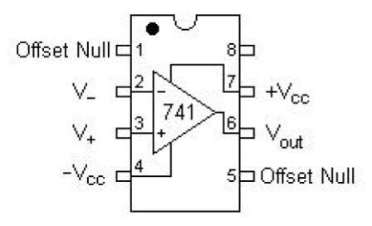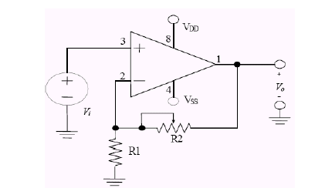

**Figure 10.2**

**Task 2: AC measurement**

1. Now, set the input signal to a 1 kHz, 0.5 VPP, 0 VDC offset (on the function generator display) Sine wave from the function generator. Use a 10kΩ potentiometer as R2. Adjust R2 to see the gain change. Can you get a gain less than unity by turning R2? Why?

Can you get a gain smaller than unity? _________________

Explain:

1. Turn the potentiometer R2 until the gain is 2 and then adjust the Vpp and DC offset to the input signal. Observe the input and output waveforms as you vary the DC offset for large Vpp (say 2.5V). Draw the input and output for a case that gives clipping, label all the axes and indicate the amplitude, and DC offset value.

Input waveform (please label axes and indicate amplitude and DC offset):



Draw output waveform and draw the ideal output in dashed line (label all the axes and indicate the amplitude and DC offset value):



Explain why clipping happens:

**Task 3: Non-idealities in Op-amp**

1. Connect the circuit of Fig. 10.2 with R1 = 10 kΩ, R2 be replaced with a resistor of 100 kΩ, VDD = 12 V and VSS = -12 V. Use a 100-mV peak 1-kHz sine wave input voltage to measure the system voltage gain.
2. Measure the high-frequency cutoff (fH) of the Op-amp using a 100-mV sine wave input and monitoring the output voltage. Starting at 1 kHz, increase the frequency until the output has decreased to 70.7% of its 1-kHz value. Record this -3 dB frequency as fH.
3. Collect two output voltage waveforms. Focus on the rising edge of the square wave response. Display and record:
   1. The response to a 50-mV peak 1-kHz square wave. Measure the slope of the rising edge of the response.
   2. The response to a 500-mV peak 1-kHz square wave. Measure the slope of the rising edge of the response.
4. Measure the slew rate (SR) capability of the op-amp from the recorded response above. Try increasing the amplitude of the input square wave. Can the output voltage attain a rate-of-change any greater than your measured slew rate?

**Questions:**

1. Compare the 1-kHz voltage gains measured with those predicted by ideal op-amp equations.
2. Compare the high-frequency cutoff measured with that predicted by the Proteus simulation.
3. Compare the slew rate measured with that predicted by the Proteus simulation. Does increasing the input voltage amplitude beyond 1 V increase the slew rate observed at the output? Why?

**Task 4: Mystery Circuit**

Using Proteus, build the inverting amplifier as shown in Fig 10.3. Use R2 = 4.7k. Input a 500 Hz 500 mVpp triangle wave. Zoom into the waveform to measure time constant RC. Compare measured time constant with theory. Add DC offset to the input signal, is there any change on the output signal? Why? What is the function of the circuit? (Experiment with the circuit to enhance your understanding.)

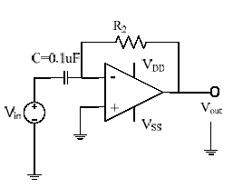

## Figure 10.3

1. Sketch the input square wave and the output wave.
2. What is the measured and calculated time constant of this circuit? Are they in good agreement?
3. Is there any change on the output signal when dc offset is included? Why?
4. ***Sketch*** the frequency response of the amplifier (gain vs. frequency).
5. What is the function of the circuit? Justify your answer.

**CONCLUSION**